Spring Framework Runtime Architecture (or Spring Modular Architecture)
Other valid names:
- Spring Framework Architecture
- Spring Runtime Module Architecture
- Spring Framework Layered Architecture
📌 Why “Runtime”?
Because these modules work together at application runtime, not just at compile time.
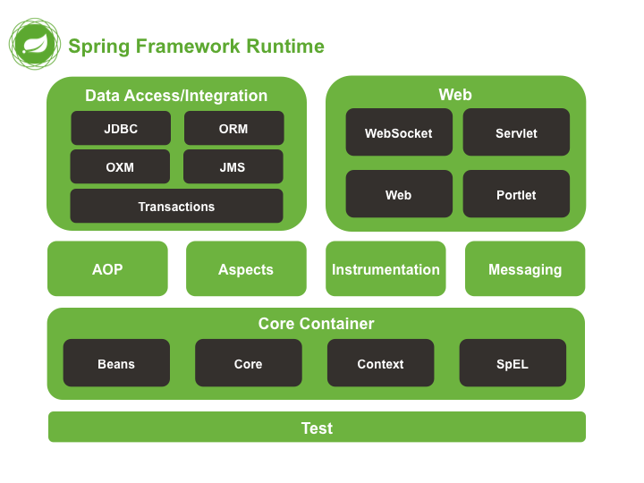
- 2️⃣ Big Picture Understanding (Before Diving In)
Think of Spring Framework as a well-organized city:
- Core Container → Foundation of the city
- Data Access → Banks, records, transactions
- Web → Roads, traffic, communication
- AOP → CCTV, security, monitoring
- Messaging → Courier & message services
- Test → Quality inspection department
Every module has a clear responsibility and they interact through Spring’s core container.

3️⃣ The Heart of Spring – Core Container
🔹 Core Container Modules:
- Core
- Beans
- Context
- SpEL
📌 If you understand this, you understand Spring.

🧠 Real-World Scenario (Used Throughout)
👉 Online Banking Application

🔹 3.1 Core Module
What it does:
- Provides fundamental Spring utilities
- Implements IoC (Inversion of Control)
📌 Without Core → Spring cannot exist
Example:
Spring decides who creates objects.

🔹 3.2 Beans Module
What it does:
- Manages Spring Beans
- Handles object lifecycle:
  - Creation
  - Initialization
  - Destruction
Banking Example:
AccountService
TransactionService
NotificationService
Spring creates and manages these objects.

🔹 3.3 Context Module
What it does:
- Acts like a container
- Reads configuration:
  - XML
  - Annotations
  - Java Config
📌 Provides ApplicationContext
Example:
ApplicationContext context =
new AnnotationConfigApplicationContext(AppConfig.class);

🔹 3.4 SpEL (Spring Expression Language)
What it does:
- Evaluate expressions dynamically
Example:
@Value("#{account.balance > 1000}")
boolean eligible;
📌 Used for dynamic values & conditions

🔗 How Core Container Connects Everything?
Every other Spring module depends on Core Container
Without Core:
- No Web
- No Database
- No Security
- No AOP

4️⃣ Data Access / Integration Layer
🔹 Modules:
- JDBC
- ORM
- OXM
- JMS
- Transactions

🔹 Banking Scenario
User transfers money from Account A → Account B

🔹 4.1 JDBC
What it does:
- Simplifies database operations
- Removes boilerplate JDBC code
jdbcTemplate.query("SELECT * FROM account");

🔹 4.2 ORM
What it does:
- Integrates Hibernate / JPA
- Object ↔ Table mapping
@Entity
class Account {
@Id
int id;
}

🔹 4.3 OXM
What it does:
- Object ↔ XML conversion
Used in:
- SOAP services
- XML-based integrations

🔹 4.4 JMS
What it does:
- Asynchronous messaging
Bank Example:
- Transaction completed
- Message sent to notification system

🔹 4.5 Transactions
What it does:
- Ensures ACID properties
@Transactional
public void transferMoney() { }
📌 Either full success or full rollback

5️⃣ Web Layer
🔹 Modules:
- Servlet
- Web
- WebSocket
- Portlet

🔹 5.1 Servlet
- Based on Servlet API
- Foundation for Spring MVC

🔹 5.2 Web (Spring MVC)
Handles:
- Controllers
- REST APIs
- Request mapping
@GetMapping("/balance")
public double getBalance() { }

🔹 5.3 WebSocket
Used for:
- Real-time updates
- Live notifications
Example:
- Instant transaction alert

🔹 5.4 Portlet
Used in:
- Enterprise portals
- Dashboard-based applications
(Less common today)

6️⃣ AOP & Aspects Layer
🔹 Modules:
- AOP
- Aspects
- Instrumentation

🔹 6.1 AOP (Aspect Oriented Programming)
What it solves:
- Cross-cutting concerns
Examples:
- Logging
- Security
- Transactions
@Before("execution(* transferMoney(..))")
📌 No code duplication

🔹 6.2 Aspects
- Defines where & when AOP logic runs

🔹 6.3 Instrumentation
- Bytecode manipulation
- Performance monitoring
Used by:
- Profilers
- Monitoring tools

7️⃣ Messaging Module
Purpose:
- Event-driven communication
- Decoupled systems
Example:
- Transaction done → Event published
- SMS service listens → Sends message

8️⃣ Test Module (Bottom Layer)
🔹 Why at Bottom?
Because testing supports every module

🔹 What it provides:
- JUnit integration
- Mockito support
- Spring Test Context
@SpringBootTest
class AccountServiceTest { }

9️⃣ How Everything Connects (Flow)
🔁 End-to-End Flow (Banking App)
1️⃣ User hits REST API (Web)
2️⃣ Controller calls Service (Core Container)
3️⃣ AOP logs request (AOP)
4️⃣ Service calls Repository (Data Access)
5️⃣ Transaction begins (Transactions)
6️⃣ DB updated (JDBC / ORM)
7️⃣ Commit / Rollback
8️⃣ Message sent (Messaging)
9️⃣ Response returned (Web)
📌 All powered by Core Container

🔟 One-Line Summary
“This diagram represents the Spring Framework Runtime Architecture, showing how modular components like Core Container, Data Access, Web, AOP, Messaging, and Testing work together at runtime to build scalable enterprise applications.”

